Fetch data from JSON to React Component

Create Json file named products.json in component folder

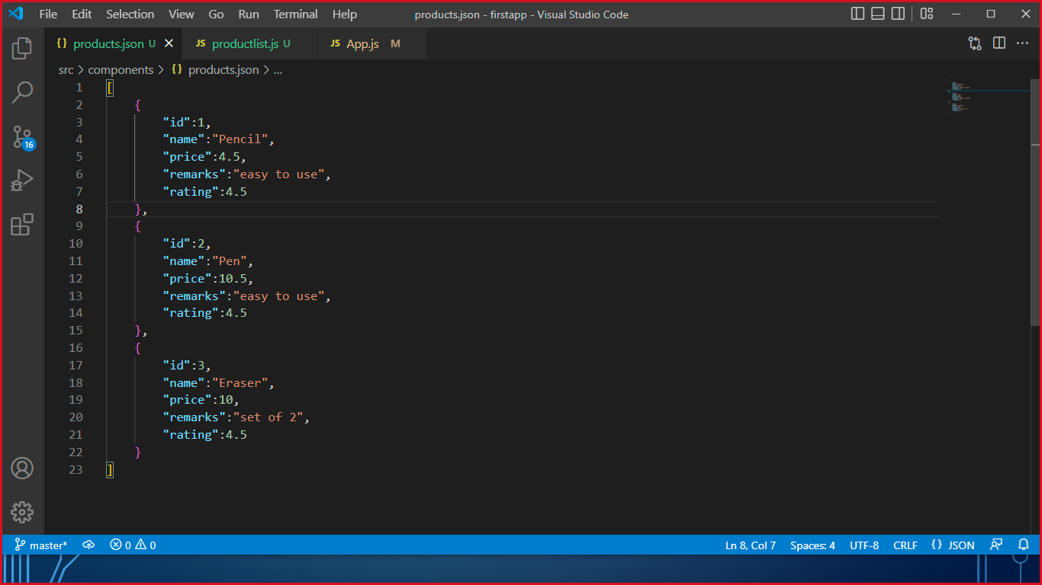

Create Product List Component import json file to get the JSON array

Once you have JSON Array you can iterate using MAP and return the value in the form of Rows.

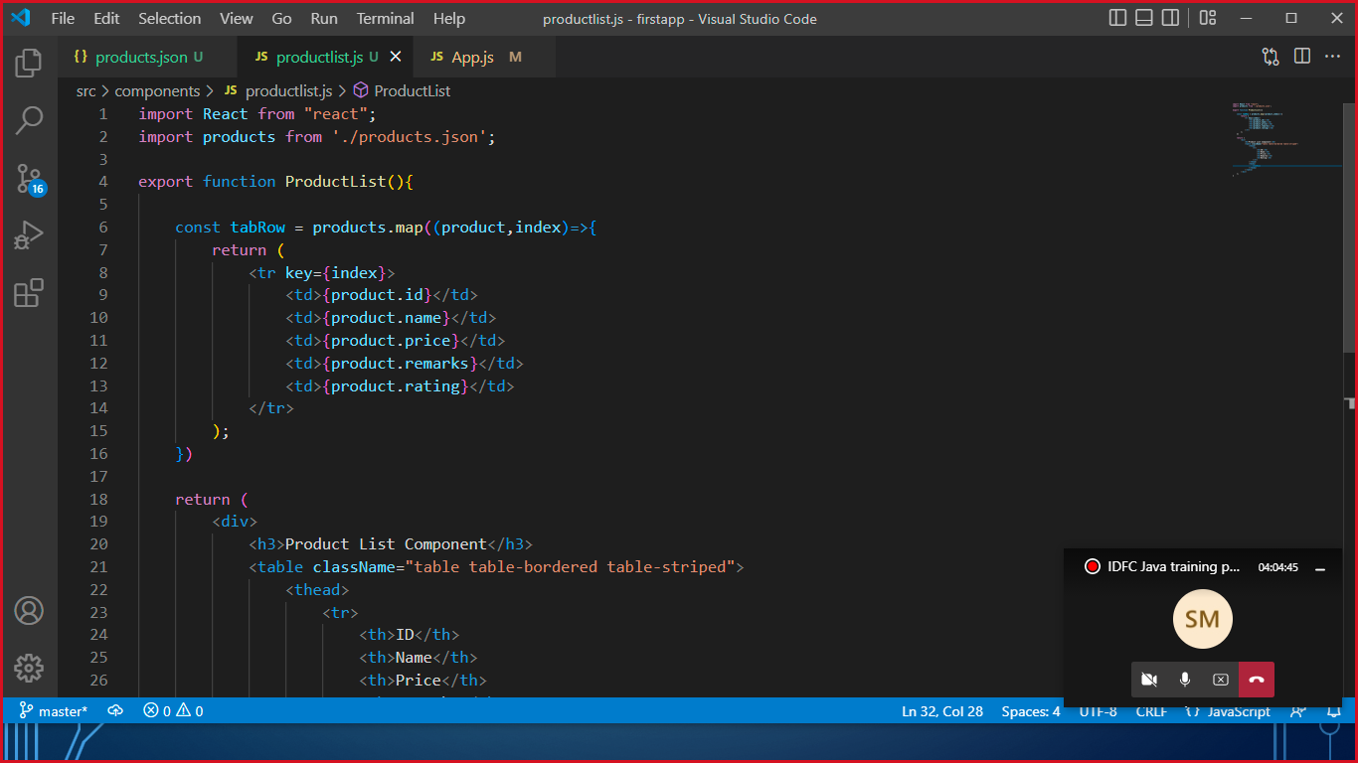

Display Data using table in return method.

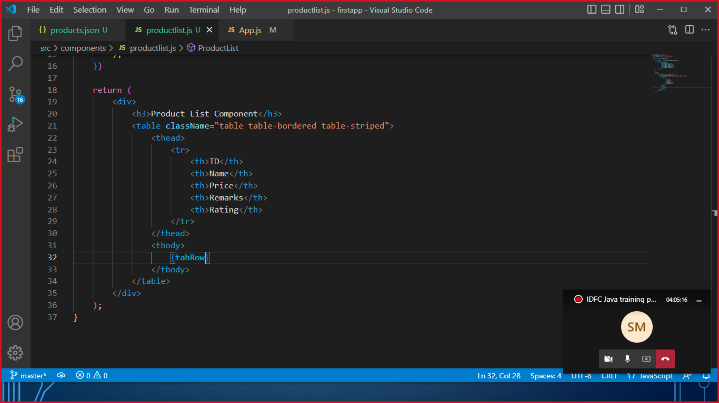

Load the component in App.js

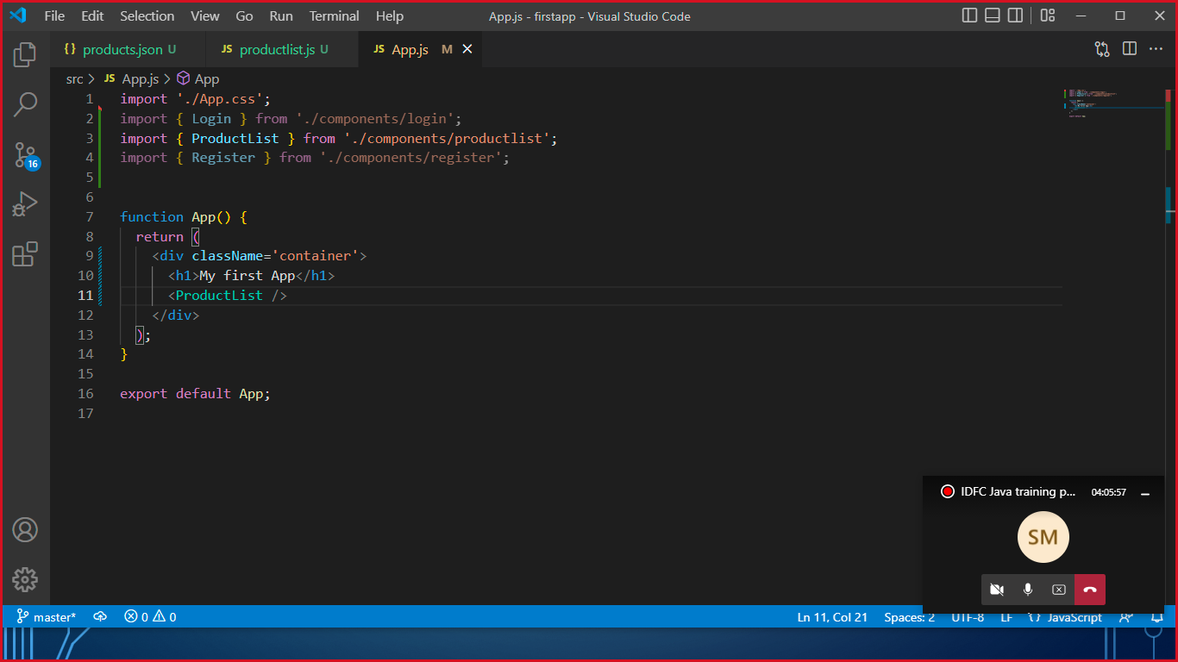

Output

